Peter Pan Live
(On December 4, 2014, I live tweeted Peter Pan Live! from BroadwayWorld’s TV Twitter account. This is a selection of my tweets.)

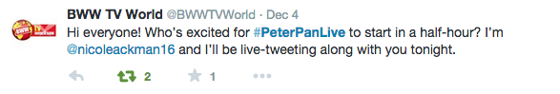
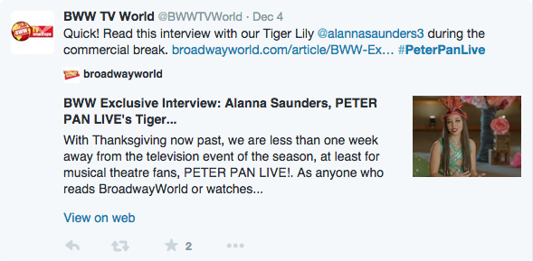
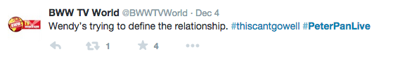
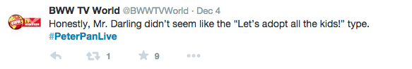
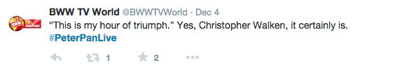
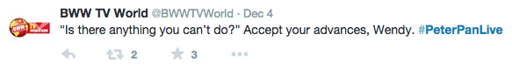
(The tweet above was favorited by Minnie Driver.)

